**Project Description**

This project contains the source code for finding out the kol score’s and rankings on the basis of given data.

The data given contains two different excel files, one is “[raw\_data.xlsx](files/raw_data.xlsx)” and another is “[profiling\_data.xlsx](files/profiling_data.xlsx)”. The “[raw\_data.xlsx](files/raw_data.xlsx)” file contain the raw data of kol’s and “[profiling\_data.xlsx](files/profiling_data.xlsx)” file contain the deep profile data of the kol’s.

Then there are two different input text files for the source code are also present namely, “[input\_raw\_data.txt](files/input_raw_data.txt)” and “[input\_profiling.txt](files/input_profiling.txt)”. The “[input\_raw\_data.txt](files/input_raw_data.txt)” file contains the data which is to be used for finding the kol rank’s and similarly also in “[input\_profiling.txt](files/input_profiling.txt)” but this file also contains the ‘Sheet Name’ at the starting of every line from which data is to be extracted.

* Enter the particulars in the “[input\_raw\_data.txt](files/input_raw_data.txt)” as:
* column\_name,attributeofcolumn,weightage from the raw data file

For example:-

* + Project\_Data\_Point,CONGRESS,4
  + Project\_Data\_Point,PATIENT GROUP,2
* Enter the particulars in the “[input\_profiling.txt](files/input_profiling.txt)” as:
* Sheet\_name,column\_name,attributeofcolumn,weightage from the profiling data file.

For example:-

* Conference Engagements,Event\_Type,Congress,4
* Conference Engagements,Event\_Type,Congress,Other Topics,Breast Cancer,10
* Publications,Publication\_Type,Journal,Other Topics,Breast Cancer,10

**NOTE**: - Entries Restriction is there with both the input text file, which can be viewed in “<Restrictions_on_input.txt>” because some criteria is being selected in source code. Here is the source code criteria of entering the values in column. “<Codefile.txt>”

**Operating the Home (Kol Tool):-**

**The files should be uploaded with the same name as “**[**raw\_data.xlsx**](files/raw_data.xlsx)**”, “**[**profiling\_data.xlsx**](files/profiling_data.xlsx)**”, “**[**input\_raw\_data.txt**](files/input_raw_data.txt)**” and “**[**input\_profiling.txt**](files/input_profiling.txt)**”.**

To operate the tool some requirements and setup are there which is explained in “<setup.txt> ” file.

1. For Rawdata File:-

After directing to the page upload “[raw\_data.xlsx](files/raw_data.xlsx)”, “[input\_raw\_data.txt](files/input_raw_data.txt)” file; Then press “Run For Raw Data File” Button; Wait till the page load or refreshed; Then press download, as a result file like “[rawdata\_output\_rank.xlsx](files/rawdata_output_rank.xlsx)” will be downloaded.

1. For Profiling Data File:-

After directing to the page upload “[profiling\_data.xlsx](files/profiling_data.xlsx)”, “[input\_profiling.txt](files/input_profiling.txt)” file; Then press “Run For Profiling Data File” Button; Wait till the page load or refreshed; Then press download, as a result file like “[profiling\_output\_rank.xlsx](files/profiling_output_rank.xlsx)” will be downloaded.

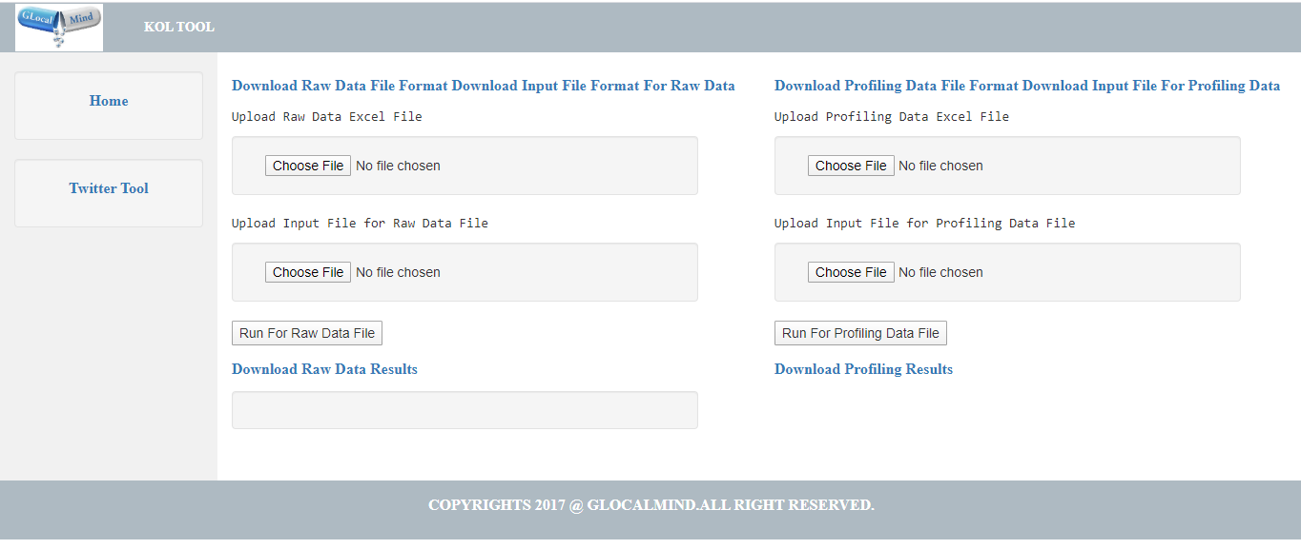

**Operating the Twitter Tool:-**

**NOTE**: -

Download the file format to upload from the [download link](files/twitter/twitter_data_format.xlsx) – “Download Input Twitter Data Format File”

**The files should be uploaded with the same name as** [**Twitter\_ID.xlsx**](files/Twitter_ID.xlsx)**.**

1. For File Input:-

After directing to the twitter\_tool page upload “[Twitter\_ID.xlsx](files/Twitter_ID.xlsx)” file; then press “Run For Getting Tweet File” Button; Wait till the page load or refreshed; Then press “Download Tweets File”, as a result file like “[user\_tweets.xlsx](files/twitter/user_tweets.xlsx)” will be downloaded.

1. For text input:-

After directing to the twitter\_tool page Enter the screen name(user name after ‘@’ ) of the person whose tweet is to be extracted; Then press “Run For Getting Tweet File” Button; Wait till the page load or refreshed; Then press “Download Tweets File”, as a result file like “[user\_tweets.xlsx](files/twitter/user_tweets.xlsx)” will be downloaded.

# 

# Result for Twitter Tool:-

# 

# Process Flow of Kol Tool:-

**Raw Data File**

**Run For Raw**

**raw\_data\_output\_rank.py**

**Data File**

**rawdata\_output\_rank File**

**On The basis of**

**Top rank Kol’s**

**Profiling Data File**

**Run For Profiling Data**

**profiling \_output\_rank.py**

**File**

**profiling\_output\_rank File**

**Result for Kol Tool:-**

